#### Engagement Letter

<on the letter head> Date: <DD MMM YYYY>,

<City>.

To

**Mr./Mrs. <Name of the Client Representative>,**

<Designation>,

<Name of the Company>,

<City>.

Dear Sir,

**Sub: Internal Audit Engagement Letter**

With regards to the discussions we had on DD/MM/YYYY and in continuation with the proposal given on DD/MM/YYYY, please find the Engagement Letter for the Internal Audit Assignment with the following Scope, Objective and Timelines:

**Scope and Objective:**1

The objectives for the internal audit are as under:

* Evaluate the business processes to ensure that they are aligned to the business objectives.
* Evaluate the compliance to both the internal policies and procedures of the company and external regulations to the extent applicable to the following key processes.
* Evaluate the effectiveness and efficiency of the identified processes and related internal controls.
* Evaluate the accuracy of accounting information systems supporting the process.
* Evaluate progressively the risks relating to the business management covering information technology and general process

1 Specific objectives of client may be elaborated here.

***Scope of work / Areas to be covered as part of Internal Audit:***

The scope shall be covering the transactions for the period <Month, Year> to <Month, Year>

***Management Process***

* Process 1
* Process 2

***Marketing***

* Process 1
* Process 2

***Contract/Project Management***

* Process 1
* Process 2

***Client Relationship Management***

* Process 1
* Process 2

***HR Process***

* Process 1
* Process 2

***Finance and Accounts***

* Process 1
* Process 2

***Administration and Logistics***

* Process 1
* Process 2

***Information Technology***

* Process 1
* Process 2

The depth and sample size under the above business processes will be decided based on Risk assessment, where incase the Risk level is high, the area shall be analyzed in depth and the sample size shall also accordingly increase. The coverage shall be based on significant risks identified in the area of concentration. The methodology adopted for internal audit deliveries is separately given in this proposal.

Methodology and Deliverables2

We have structured methodology starts from mapping the corporate vision to audit deliveries and value-add. The following chart displays the steps generally followed by us in an Internal Audit Outsourcing Service.

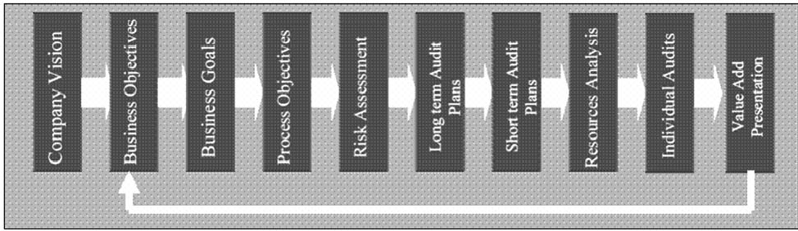

The following are the benefits for the organization from outsourcing:

* Global best methodology for handling Internal Audits
* Relevant business / process / internal audit expertise and access to best practices
* Structured deliveries with performance indicators and terms of delivery
* Saving costs and efforts for the organization and help management concentrate on core competency

Our strong methodology also includes taking the input of the top management, process management and audit management to design a solution that means value addition. Our deliverable will give a road map to make the necessary process improvements that gives a big seat for practicality of implementation of recommendations.

***Pre Audit Opening***

* General Process Understanding
* Data Analysis and Summary Preparation
* Planning of Audit

***Detailed Walk Through***

* Detailed Walk Through
* Documentation of Walk Through Results

***Risks, Checklists, Audit Programme***

* Listing of Risks and Audit Programme (Checklists)
* Generation of Exceptions through Analytics
* Planning of Audit Programme Delivery
* Execution of Audit Programme

2 Some clients may not want a detailed methodology to be given in the engagement letter.

* Compilation of Observations and Draft Reporting
* Quality Check of adequacy of Evidences and Work Paper Linking
* Supervisory Review and Confirmation

***Report Compilation***

* Preparation of Audit Report
* Circulation of the Draft Report for Management Comments
* Collection of Management Comments

***Exit Meeting***

* Fixing of the Meeting Time
* Presentation and Action Plan Preparation
* Updation of the Action Plan into the Draft Report

***Report Issue***

* Final Official Report Issue as per Standards on Internal Audit (SIAs) Issued by the ICAI
* Audit Committee Presentation (Where Applicable)
* Audit Feedback Collection

***Each Audit Report shall contain the following information:***

* Executive summary
* High, Medium, Low Risk Areas classified separately
* Detailed audit observations, covering Risks, Impact, Recommendations, Auditee Comments, Annexures of evidences
* Audit Implementation Action Plans with time lines and responsibility shall be updated after management discussion.
* Presentation to management and Audit Committee

Team, Schedule and Professional Fees:

Based on the Information provided to us with regard to the infrastructure and statistics, we estimate the following:

|  |  |  |  |
| --- | --- | --- | --- |
| **Sl No** | **Particulars / Name of the Resource** | **No of man days / man months** | **Qualifications** |
| 1 | Partner |  |  |
| 2 | Senior Manager |  |  |
| 3 | Senior Associates / Consultants |  |  |
| 4 | Associates / Consultants |  |  |
| 5 | Junior Associates / Consultants |  |  |
|  | **Total Time** |  |  |

3Taking the above deployments into account, the fee for the assignment is estimated as Rs. XXXXXXX/- excluding applicable service taxes. Incase there is any travel incidental to the delivery of the project we shall adhere to internal policies and shall be reimbursed on actual.

Resources Required

* An audit room will be set up having the sufficient no. of Table and chairs along with White board for meeting and discussion.
* Access to all the data, record, employees required for the effective performance of internal audit.
* Computers with access to company ERP, email and other systems with printing facility with adequate stationary.

Project Coordination:

We understand the importance of a project coordinator over the period of the assignment. The team shall be interacting with the process owners through the project coordinator. It is the duty of the Project Coordinator to organize the information and time of the process owners. Any delay due to coordinator or process owner shall not be the responsibility of the Internal Audit Service Provider.

Confidentiality Clause:

We shall maintain confidential all the information collected as part of the engagement and shall not disclose them unless until necessary as per the regulations of the land of assignment. Incase of need to disclose the information, we shall take the permission of the client coordinator before disclosing.

Termination Clause:

The assignment can be terminated by either parties by giving a notice in advance of atleast 1 month. Thereafter the information / documentation collected shall be returned back to the client.

4Incase of negligence, quality standards compromise, and willful default, the client shall have the right to be indemnified for all the costs till the date of termination.

3 Some clients may be interested to add a detailed Gantt chart of the project.

4 Some clients may also be interested to add a Quality Assurance Clause.

Signing of the Contract:

For XYZ & Co.,5

XYZ,

Partner

On behalf of Client

For <Name of the Client>

<Name of the Authorized Representative>

<Designation>